# FinUno Mobile Invest – Automation Testing-Index Watch - Documentation

## Test Strategy

### Overall Testing Objective:

* + To automate Index Watch module of the Mobile Invest Android app, with the help of Open source automation testing tools and an Android Device

### In Scope

* + Go to the Android play store and download “Mobile Invest” from Aditya Birla Money Ltd which is our application
  + Write 5 test cases which you feel are the most important for the Index Watch functionality
  + Use Robotium or Appium or a trial version of Sauce labs (which is cloud based at [www.saucelabs.com](http://www.saucelabs.com)) – any which can support automation without the source code in order to create automation for those 5 test cases and run them against the application

### Out of Scope

* + All functions other than Index Watch Related are out of scope

### Assumptions

* + Automation Tools to Be Used: Robotium or Appium 1.4.16 or a trial version of Sauce labs, Selenium WebDriver 2.53, coded in Java with JDK 1.8 and JRE 1.7
  + Mobile Invest is a Hybrid app and could be automated with respect to Native context only, as the Web View flag is not enabled in the app that is in production
  + The Mobile Invest application can be run without an account
  + The app has been pre-installed on the phone from Google play store and initial setup has been completed i.e. enter cell no. and submit and by default Home page is displayed on opening every other time

### Issues and Risks

* + Not all flows can be automated on the hybrid app, as the WebView elements can’t be located effectively by the Appium’s UIAutomator, if the WebViews flag is not enabled in the Source code of the Android app

## Test Suite

### Test Scripts or Test Cases:

* Mobile Invest Test Suite contains the following Tests performed on Index watch function, a brief description of the Test scripts is as follows:

NOTE: Appropriate comments have been embedded within the Test scripts for better understanding

### Package: com.mobileinvest.tests

* + **MobileInvestHome.java**
    - Verify whether a different Index could be selected from the settings menu/SetIndicesFromIndexSettings ()
    - Verify whether the indices selected on Index Settings page are displayed on the Home page/VerifyIndicesFromIndexSettings ()
  + **IndexWatchPage.java**
    - Verify whether BSE could be selected from the drop down list on the Index Watch page/ SelectBSE_from_Dropdown()
    - Validate whether BSE was selected and corresponding indices under BSE are displayed/validate_BSE_IndexWatchPage ()
  + **NiftyITPage.java**
    - Verify the navigation to Nifty IT page, where the Charts are displayed /Open_NiftyITPage()
    - Verify whether the Chart type could be changed to Candle Stick Chart /Select_CandleStick_Chart ()

### Package: com.mobileinvest.utilities

* + **InitiateApplication.java**
    - Start() – Sets up desired capabilities and requests to the Appium Server
    - Close()- Ends the session
  + **TakeScreenPrint.java**
    - TakeScreenSuccess() – is called when a Test step is successful and a screenshot is taken and placed under /Screenshots folder
    - TakeScreenFail() – is called when a Test step fails and screenshot is taken and placed under /Screenshots folder
  + **Listener.java**: This class extends the Listener interface ITestListener and implements few of its methods:
    - onTestFailure(),takes screenshot if a test fails
    - onTestSkipped, displays message with Test case info when a test is skipped
    - onTestStart(),displays message with Test case info when a test execution is Started
    - onTestSuccess(),displays message with Test case info when a test execution is complete

### Test Data:

For reasons taking into account the scope of testing the test data has been embedded into the test scripts themselves.

## Test Environment Setup/Procedure

### Download and Install Java – JDK and JRE

* + Download and install the Java from the original website
  + Set System environment variable
    - Go to Windows System Settings->Advanced System Settings->Click Environment Variables->System Variables dialog box
    - JAVA_HOME and
    - Path: C:\Program Files\Java\jdk1.8.0_101

### Download Android SDK

* + Download Android SDK for Windows from the link and extract to a local folder <https://dl.google.com/android/android-sdk_r24.4.1-windows.zip>
  + Open SDK Manager.exe from the unzipped Android SDK folder and Select and install the required packages
    - Tools – Select all packages under that folder
    - Select Android folders as per Your Device’s Software version (e.g 6.0, 5.0..)
  + Create & Edit System Variables in your Windows (Please be careful while editing, DO NOT delete any of the entries:
    - Go to Windows System Settings->Advanced System Settings->Click Environment Variables->System Variables dialog box
    - Create New System Variable:
      * Variable name: ANDROID_HOME
      * Variable value: “full path where the SDK was unzipped”
        + E.g. C:\Users\....\android-sdk-windows
    - Edit “Path” system variable and add the below to the list of entries:
      * %ANDROID_HOME%\tools
      * %ANDROID_HOME%\platform-tools
  + Go to Win Command Line and type
    - “Android”, then press Enter, SDK Manager should open up, which means the System variables have been configured correctly
    - “ADB” command displays the list of devices connected to your PC

### Download and Install Appium

Before downloading and installing Appium in windows, please make sure below prerequisites are fulfilled:

1. JDK Installed.
2. Android SDK downloaded and Path environment variables are Setup.

**For downloading Appium for windows**,

1. Go to [**THIS PAGE**](http://appium.io/).
2. Click on Download Appium button.

[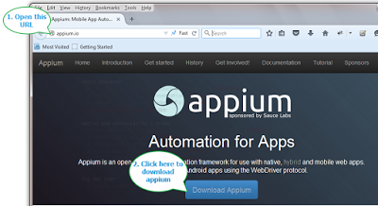](http://1.bp.blogspot.com/-L_FG8BxHKxk/Vc__2D9l2dI/AAAAAAAAB7w/I3rSRom-wkU/s1600/download%2Bappium%2Binstaller.png)

It will download zip file.

1. When download completes, extract the zip file. You will get AppiumForWindows folder as shown below.

[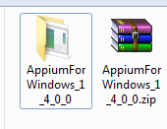](http://1.bp.blogspot.com/-s6M4pwxASaY/VdADYLmcACI/AAAAAAAAB8E/QKaJkOutRro/s1600/appium%2Binstallation%2Bfolder.png)

**Install Appium:**

1. Open AppiumForWindows folder. "appium-installer.exe" file will be there.
2. Double click on "appium-installer.exe" file to install Appium.
3. After installation, launch Appium.[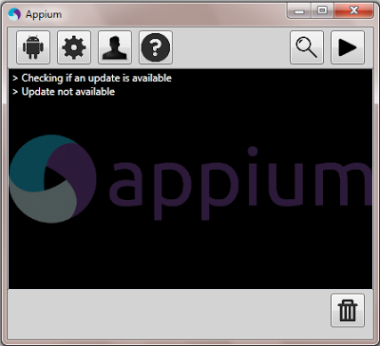](http://4.bp.blogspot.com/-lkbj3hDTYt0/VdAKT22uBiI/AAAAAAAAB9Q/Hz9mjegQ0-g/s1600/8+-+start+appium.png)

Appium is installed and ready to use.  
  
**Configure Appium**

Appium will launch with default configuration parameters. To reduce errors during software automation test execution, we need to set/modify few Appium parameters as per your requirement if they are wrong or not set properly. See below:  
  
Android Settings :

1. Click on Android Settings button as shown in bellow image.
2. **Important:** Always select ‘No reset’ check box under Application in Android settings
3. General Settings

Click on General Setting’s button as shown in bellow image.

Please verify Server Address is : 127.0.0.1 and Port number is : 4723.

1. Un-check Pre-Launch Application check box if it is checked.

[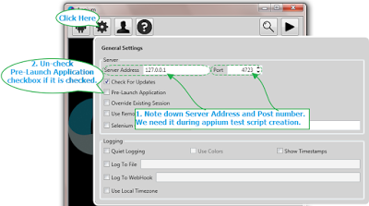](http://1.bp.blogspot.com/-6DhUYzSPmnU/Vd22rkzMqVI/AAAAAAAACHY/ZdWNZsr3GdY/s1600/set+appium+general+settings.png)

1. Leave all other settings as it is.
2. Click play button to start the Appium server.

### Download Selenium WebDriver

* + I have already downloaded and added the Selenium WebDriver libraries to the project folder "C:\Users\....\MobileInvestDemo\lib"

### How to Run Test Scripts?

#### Set Up Android Mobile Device and make changes to a test script

1. Connect the Android device to your PC via USB and set it up to “File transfer” Mode
2. Go to the Project folder: C:\Users\....\MobileInvestDemo\src\com\mobileinvest\utilities\InitiateApplication.java
3. Open InitiateApplication.java in an editor like Eclipse or a Note pad and change the following:
   * 1. capabilities.setCapability("deviceName", "HTC One_m8"); //Replace "HTC Once_m8" with your Device Name
     2. capabilities.setCapability("platformVersion", "6.0"); //Replace "6.0" with your Device's Android Version

#### Configure Appium

Open Appium and please set the Setting as per below

* + - Android Settings :
    - Click on Android Settings button as shown in bellow image.
    - **Important:** Always select ‘No reset’ check box under Application in Android settings
    - **Start the Appium server**

#### Running the Mobile Invest Test suite using Run.bat

Go to the Project folder and click on **run.bat** to start the test execution from the Windows Command Prompt

## Test Results

* After each time the Mobile Invest Test suite is executed, the test results can be found in HTML file located in the Project folder \MobileInvestDemo\test-output\index.html
* Open index.html in a browser to see results
* Note: The file is modified with every Run. Save the results to some other folder, if required for future use.